Case 19-AM,C-TAINO-Cohoba Inhaler-Frog Sculpture

This is a unique piece... A stone inhaler in a shape of an frog that came from Dominican Republic, full in details. One very best piece, look the photo to see more of it.

is 4'' long and 2''1/4 wide.

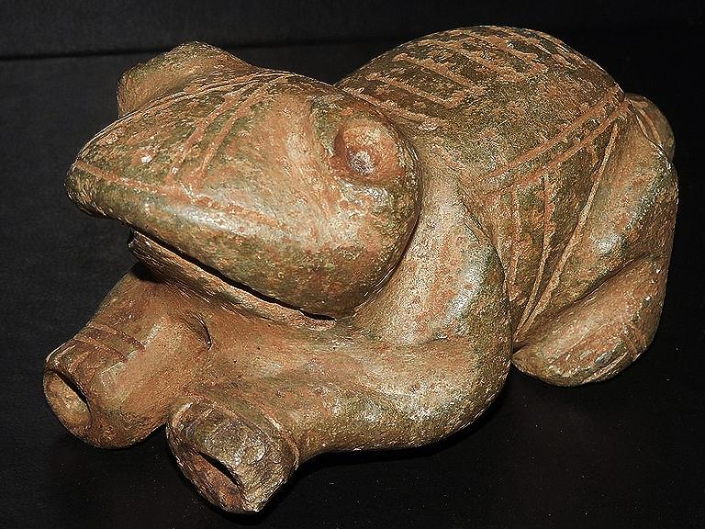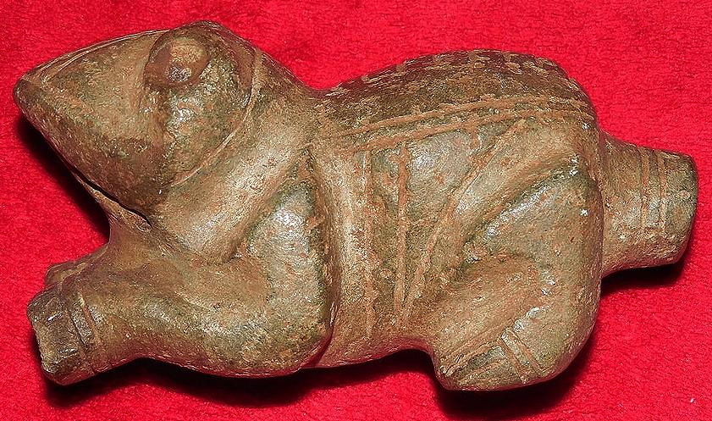

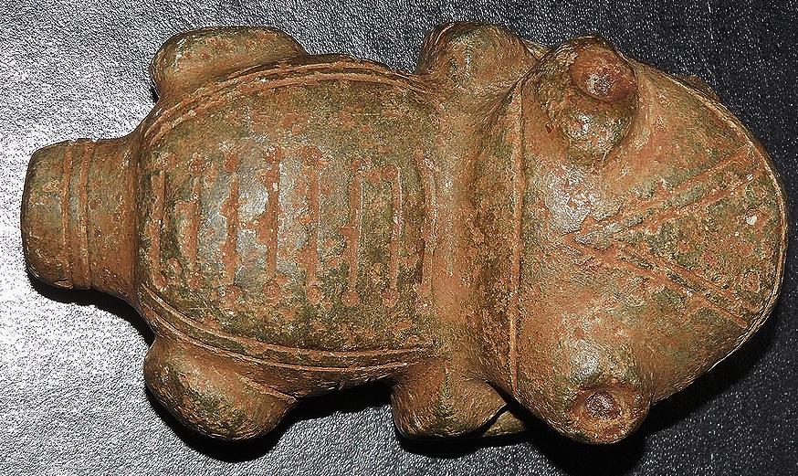 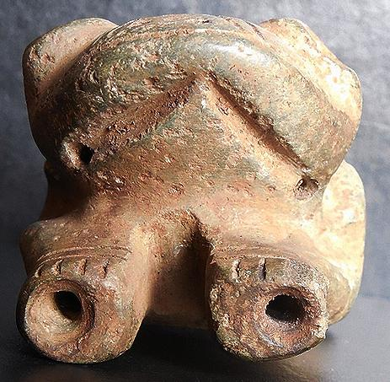

# Order details

## Sales order

Sold by [the*caciques](http://myworld.ebay.com/the*caciques) ( [76](http://feedback.ebay.com/ws/eBayISAPI.dll?ViewFeedback&userid=the*caciques) )

### Delivery package 1 of 1

Estimated delivery Wednesday, Jan 6, 2016 - Saturday, Jan 9, 2016

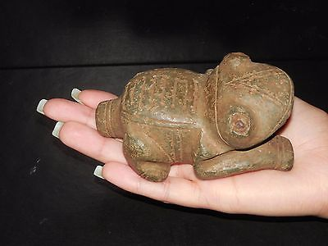

#### [TAINO CEREMONIAL PRE- COLUMBIAN STONE FROG INHALER.](http://www.ebay.com/itm/111859485632)

|  |  |
| --- | --- |
| Item price | $244.00 |
| Quantity | 1 |
| Item number | 111859485632 |
| Shipping service | USPS Priority Mail |

## Shipping address

Ralph J Coffman Jr

149 Atlantic Ave

Swampscott MA 01907-2427

United States

## Order total

|  |  |
| --- | --- |
| Subtotal | $244.00 |
| Shipping | $5.00 |

**Total**

$249.00